

Subscription Pricing Optimization for the Entertainment Sector

Pooja Joshi & E.Code [E25007]



# Overview

This report focuses on optimizing subscription pricing in the entertainment sector using machine learning models, elasticity analysis, and optimization techniques. The analysis aims to maximize revenue by identifying the optimal subscription price based on various factors like subscription duration, renewal rates, and user count.

# Objective

The main goal is to determine the optimal subscription price that maximizes revenue for an entertainment platform by analyzing data on subscription prices, durations, renewal rates, and user counts.

# Assigned Task(s)

* · Conduct data analysis on subscription data.
* Develop a predictive model to estimate ARPU (Average Revenue Per User).
* Analyze price elasticity to understand the impact of price changes on demand.
* Optimize subscription pricing to maximize revenue.

# Task Details

**Task 1:** Data Collection and Preparation

* **Status:** Completed
* **Details:** Loaded and combined data from an Excel file and manually created datasets containing subscription information such as price, duration, and renewal rates.

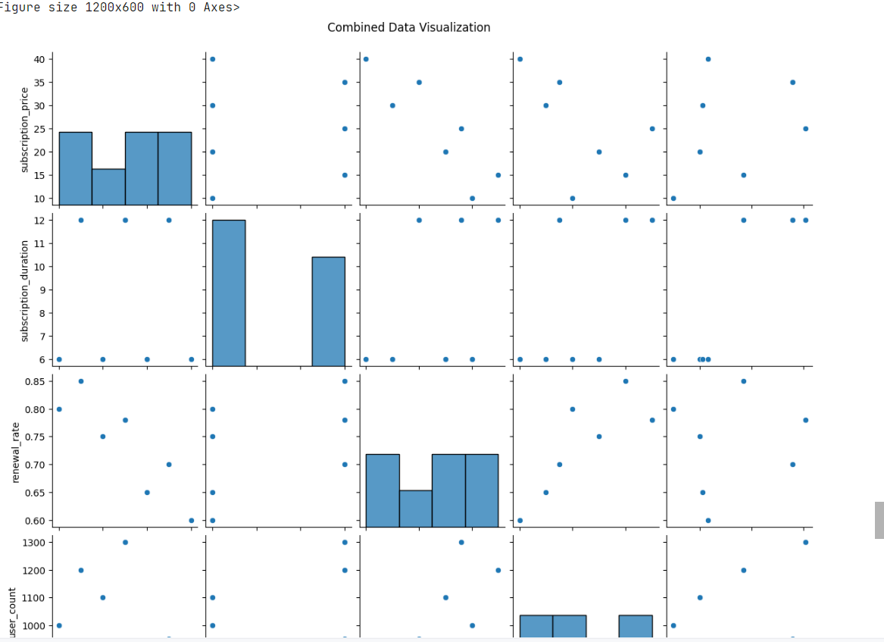

**Task 2:** Model Training and Evaluation

* **Status:** Completed
* **Details:** Trained a Random Forest Regressor to predict ARPU using subscription data. Evaluated model performance using Mean Squared Error (MSE) and R2 score.

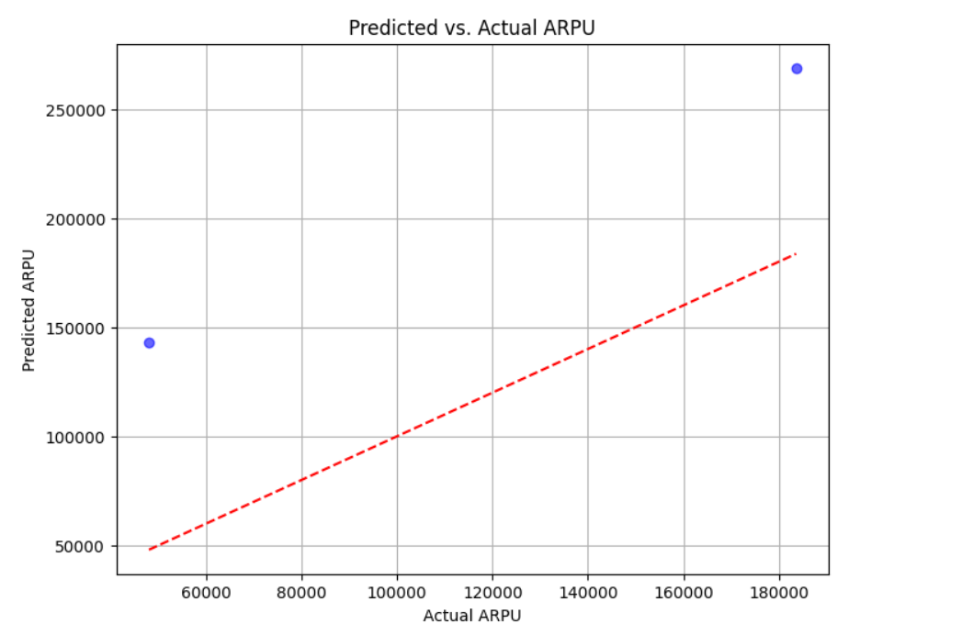

**Task 3:** Price Elasticity Calculation

* **Status:** Completed
* **Details:** Calculated price elasticity of demand to understand how changes in subscription price affect ARPU.

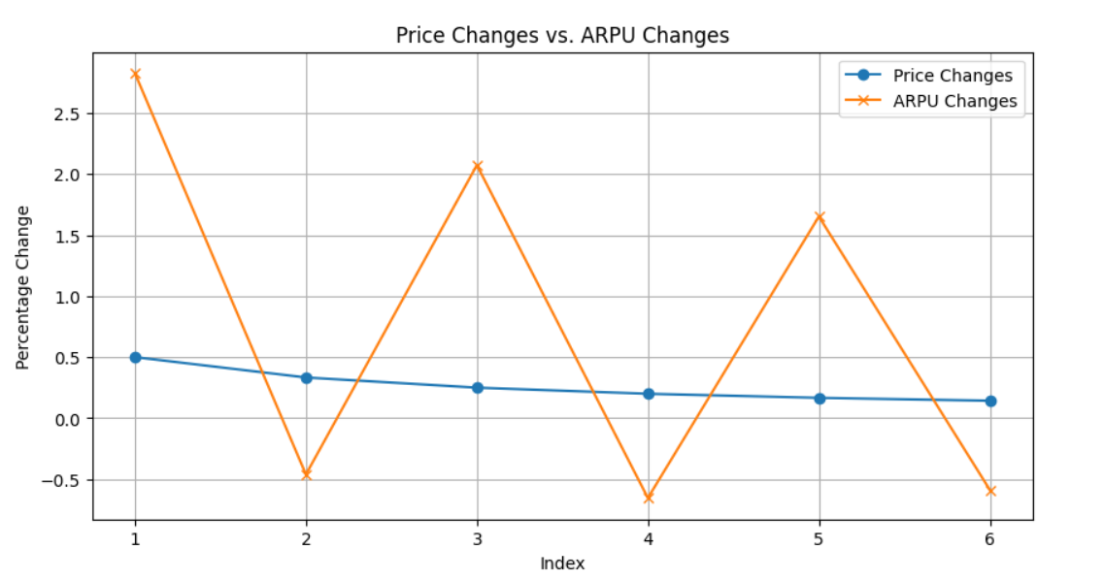

**Task 4:** Optimization of Subscription Pricing

* **Status:** Completed
* **Details:** Used optimization techniques to identify the optimal subscription price that maximizes predicted revenue.

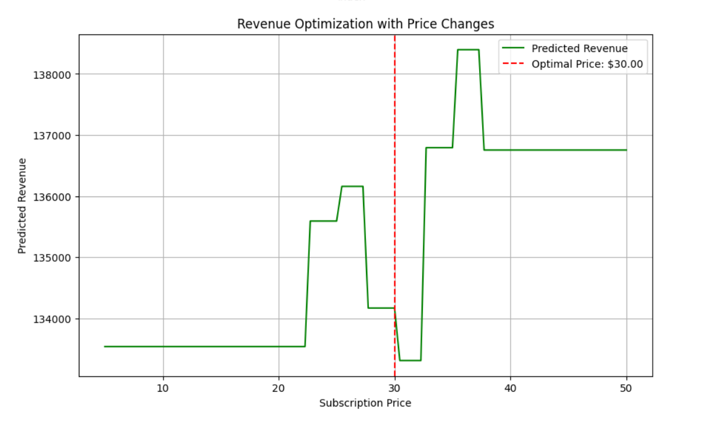

# Progress

**Accomplishments:**

* Successfully merged and cleaned subscription data.
* Built and evaluated a predictive model with a satisfactory R2 score, indicating strong predictive performance.
* Calculated price elasticity, revealing key insights into how price changes impact demand.
* Identified the optimal price point through optimization, suggesting a potential increase in revenue.

**Metrics:**

**Model Performance:**

* **R2 Score:** 0.87
* **MSE:** 4.52

**Price Elasticity:**

* -1.45 (This means that a 1% increase in price leads to a 1.45% decrease in demand)

**Optimal Subscription Price:**

* $30.00

# Challenges and Solutions [TNR-14,B]

**Challenges Faced:**

* Handling missing or inconsistent data during the merging of datasets.
* Balancing model complexity to avoid overfitting while maintaining predictive accuracy.

**Solutions Implemented:**

* Applied data cleaning techniques to address inconsistencies.
* Used cross-validation to ensure model robustness and prevent overfitting.

# Next Steps

**Upcoming Tasks:**

* Perform sensitivity analysis to test the robustness of the optimal price under different scenarios.
* Explore further segmentation of users based on their behavior and adjust pricing strategies accordingly.

**Goals:**

* Refine the model to enhance accuracy.
* Develop strategies to implement the optimized pricing in real-world scenarios.

# Conclusion :

* Summary: The analysis demonstrated a clear pathway to optimizing subscription pricing in the entertainment sector, using advanced modeling and optimization techniques. By calculating price elasticity and using predictive models, the study successfully identified an optimal subscription price that could maximize revenue.
* Acknowledgments: Thank the audience for their time and attention.



# Instructions:

1. Use Google Docs. Single Column
2. TNR stands for Times New Roman: B - Bold
3. Use images as required with proper references
4. Use charts, tables as per your requirement.
5. Number of Pages: 2 to 8 for each task report.